**Title:**

Scheduling Softball Series in the Rocky Mountain Athletic Conference

**Abstract:**

The Rocky Mountain Athletic Conference is a Division II National Collegiate Athletic Association conference that offers, inter alia, women’s softball. Within the conference, four-game series are played against every other conference team according to a temporally constrained schedule. Manually generated schedules result in imbalances, such as breaks of multiple home or away series and away-series season openers and closers for the same team, and fail to mitigate weather-related series disruptions. Our integer-programming–based schedules eliminate these problems while ensuring that all requisite series are played. In this paper, we present a 40-game schedule; we do not present 36- and 44-game schedules, which are nearly equivalent. For its 2011 softball season, the Rocky Mountain Athletic Conference adopted the 40-game schedule from these three schedules.

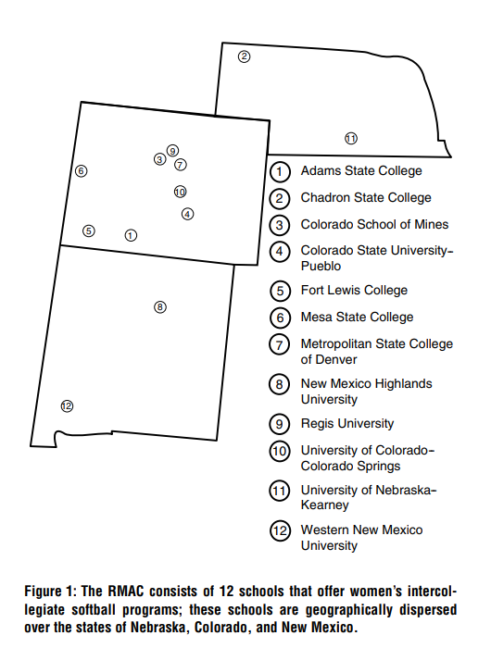

**Literature Review:**

[Farmer, A., J. Smith, L. Miller. 2007. Scheduling umpire crews for professional tennis tournaments. Interfaces 37(2) 187–196.](Scheduling%20Umpire%20Crews%20for%20Professional.pdf)

[Urban, T., R. Russell. 2003. Scheduling sports competitions on multiple venues. Eur. J. Oper. Res. 148(2) 302–311.](Scheduling%20sports%20competitions%20on%20multiple%20venues.pdf)

[Croce, F., D. Oliveri. 2006. Scheduling the Italian football league. Comput. Oper. Res. 33(7) 1963–1974.](Scheduling%20the%20Italian%20Football%20League——an%20ILP%20based%20approach.pdf)

[Durán, G., M. Guajardo, J. Miranda, D. Sauré, S. Souyris, A. Weintraub. 2007. Scheduling the Chilean soccer league by integer programming. Interfaces 37(6) 539–552.](Scheduling%20the%20Chilean%20Soccer%20League%20by%20Integer%20Programming.pdf)

**Problem Statement:(大概)**

**每看完一段话，就会复制到这个文件中，特别对于体育规划来说，会有很多文字去解释过程。其中，举例论述等不必要的文章段落会进行删去。不过，大致都是近乎原文。**

According to the NCAA rule book, softball teams are allowed to begin playing games on February 1 of each year. However, the RMAC does not begin conference play until the last weekend in February. This leaves approximately three weeks at the beginning of the season during which RMAC teams may engage in play against teams in their region (but not in their conference). This regional play contributes toward regional standings, which are very important for each team in the RMAC; they determine the number of RMAC teams that obtain a bid to the end-of-season regional tournament. By allowing teams the opportunity to compete against other conferences to improve regional standings, the RMAC as a whole can improve its national recognition and accreditation. However, preseason regional play leaves only 10 weekends for conference play during which 12 teams must face one another.

To play all the teams in the conference, the 2010 actual schedule offered two solutions that worked in tandem: (1) the schedule designated pairs of sister schools that play two games during two different weekdays of the regular season (i.e., four games); and (2) the schedule incorporated “pod play”—a weekend within the season when four teams meet at a single location and each team plays two games against two other teams in that same location, rather than the usual one-versus one (four-game) match-up. We change the featured schedule structure by eliminating weekday sister-school play. By eliminating weekday play, our schedule allows softball coaches to schedule regular weekly practice around which student athletes can accommodate their classes.

Specifically, we require that each RMAC team play every other RMAC team exactly once. We enforce this requirement as follows: (1) either a team plays an opponent in one four-game weekend regular series or (2) a team plays two games against two different opponents in a four-game weekend pod series. Additionally, because conference tournament standings are based on east and west divisional records, we reserve the four-game regular series for play within a team’s own (east or west) division, because a four-game regular series provides more information for determining the better team within the series than the pod play, which has fewer (i.e., two) games against the same team. The RMAC wishes to have more information regarding the relative strength of two teams within the same division to enable it to make a better judgement about conference tournament standings. Therefore, we allow only teams that are not within the same (east or west) division to play each other in a pod series. During the pod weekend, three schools host a pod in which four teams play. Clearly, teams can only play each other in a pod weekend if they both take part in the same pod; additionally, the school hosting a pod must play in that pod.

Our model balances home and away series by allotting each team in the RMAC exactly four weekends of home play if hosting a pod and exactly five weekends of home play otherwise. In the remaining weekends, the team is a visitor. This allows each team the opportunity to play the same number of opponents on its home field.

Teams either start their conference play at home and end the season away or vice versa, with the remaining home and away series generally falling on alternating weekends. If the home (away) series do not fall on alternating weekends, we penalize the repetition. Specifically, we penalize the occurrences of home-home breaks within a school’s schedule. Our objective function seeks to minimize the penalties incurred from violating this single, elasticized constraint. We disallow any school from having more than one home-home break.

The home series are allocated to prevent any team from having too many consecutive away series. Our model differentiates “close” and “far” series relative to each individual school with an RMAC softball program. For any given school, we establish “far” teams based on the greatest gap in reasonable driving time. Traveling to consecutive away series tires a team physically, results in more missed class time in a short time frame, and impairs practice quality. Teams playing their third consecutive away weekend could be viewed as having a disadvantage against the home team both because of stress caused by scrambling to make up missed academic work and because of time spent in buses or vans rather than out on the field. Our schedules eliminate back-to-back far-away traveling weekends; they also eliminate three consecutive weekends of away travel, regardless of the distance of travel.

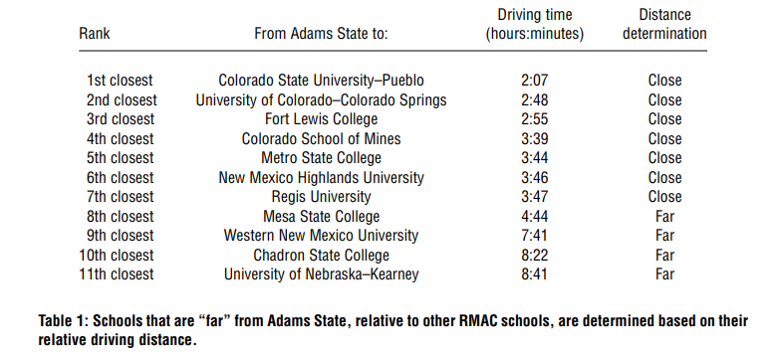

**Table 1** demonstrates how we choose corresponding “far” schools for one school, Adams State. We first rank driving time from Adams State to each other RMAC school in ascending order. We use driving time as the metric because virtually all schools drive to competitions. Given the relative driving times, we subjectively and manually search for a break in the list such that at least approximately half of the schools are considered close, but that the break is significant enough to differentiate “close” and “far” schools. Although a significant difference (nearly an hour) of driving time occurs between the University of Colorado–Colorado Springs and the Colorado School of Mines, placing the dividing line between these two schools would leave only three schools in the “close” category, which might overly constrain our model. Therefore, we continue to search down the list for another significant difference in driving time. We find such a difference (one hour) for Adams State between Regis University and Mesa State College; therefore, we place the dividing line after Regis University, resulting in seven “close” schools.

To further strengthen our model, we add weather considerations. Specifically, early-season play is often disrupted by poor (usually cold, snowy) conditions. Schools less affected by poor weather include Colorado State University–Pueblo, Fort Lewis College (because of close access to an alternate, warm venue), Mesa State College, Metro State College, New Mexico Highlands University, Regis University, and Western New Mexico University. We refer to these schools as “warm-weather schools.” (We grant that this is a relative designation!) We then place a constraint in the model ensuring that two of the first four series are played at warm-weather schools. we do not consider game rescheduling in our model.

**Results:**

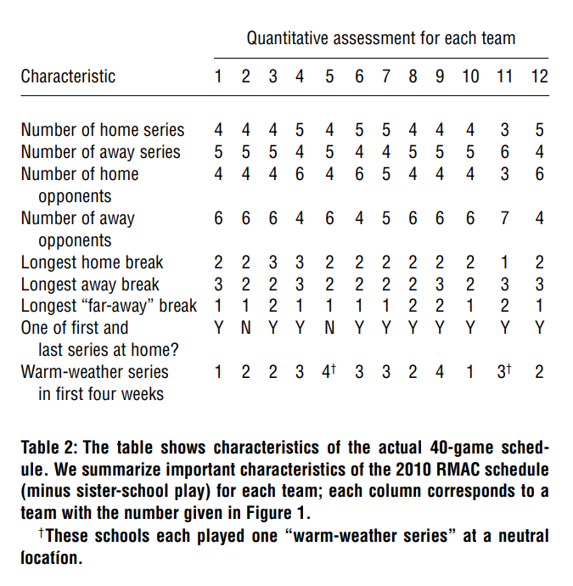

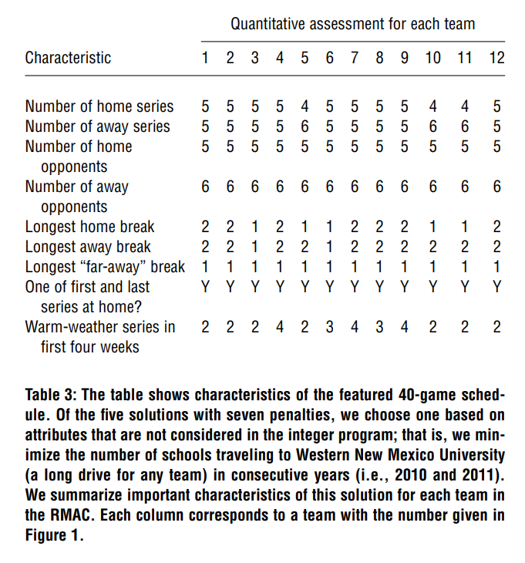

**Formulation:**

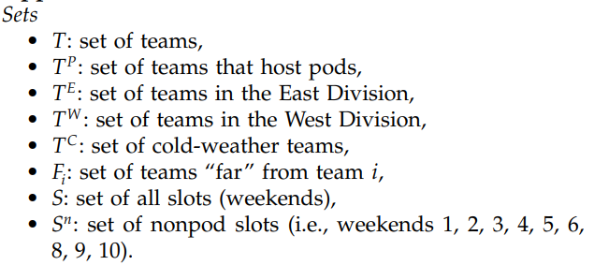

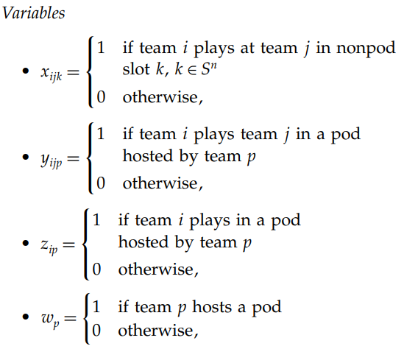

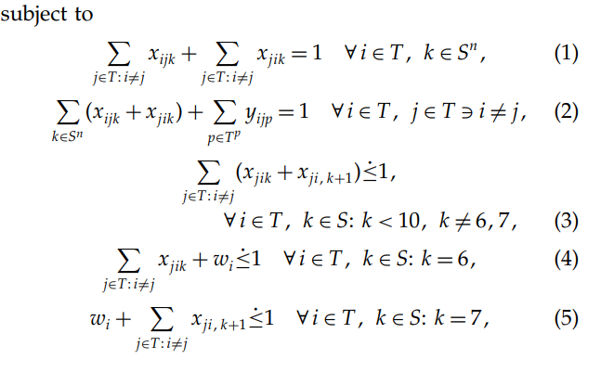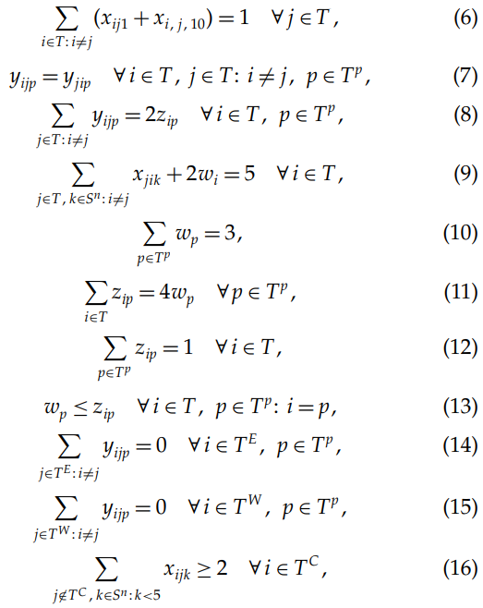

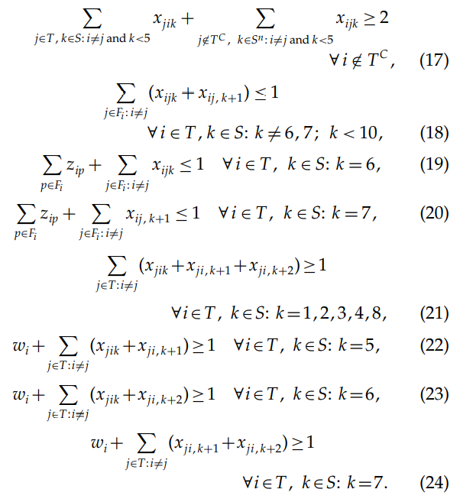

Constraints (1) require that in each non pod weekend, a team plays exactly one other team, either at home or away. Constraints (2) require that each team plays every other team once during the season, either at home, away, or in a pod (at home or away). Constraints (3)–(5) penalize two home series in a row, either two regular series, series in which a hosted pod is preceded by a home series, or in which a hosted pod is followed by a home series, respectively. Constraints (6) ensure that a team either starts its season at home or ends it at home. Constraints (7) ensure that if team i plays team j in a pod, then team j plays team i in the same pod. Constraints (8) guarantee that a team plays two other teams in each pod slot. Constraints (9) force there to be exactly five home series for each team, where hosting a pod counts as two home series. (This forces each team to play exactly five opponents at home.) Constraints (10) require that in the pod weekend, three schools host a pod. Constraints (11) ensure that a pod comprises exactly four teams. Constraints (12) require that a team must play in a pod in the pod weekend. Constraints (13) insist that if a team hosts a pod, then it must play in that pod. Constraints (14) and (15) preclude teams from the same division, east or west, respectively, from playing each other in a pod slot. Constraints (16) force schools in cold-weather areas to play at least two of their first four series away at schools in warm-weather areas. Constraints (17) force schools in warm-weather areas to play at least two of their first four series either at home or away at schools in warm-weather areas. Constraints (18)–(20) ensure that no team plays two consecutive “far-away” series. Constraints (21)–(24) require that each team play at home at least once over any consecutive three-weekend series. The four different variations of this constraint address the different slots in which the pod series lies relative to the regular four-game series.

第一篇学习报告，paper中有较多论述，因此我采取了report的形式,以后的篇章中会有不同。

This is my first study report, there are many descriptions in the paper, so I just compiled as the same format. The form would be improved in the other papers.